Operational Acceptance Testing (OAT)

Definition
# Source: Chatgpt (GPT‑5 Mini) at [8/22/2025]
(Also known as Production Acceptance Testing)
Operational Acceptance Testing (OAT) is a type of acceptance testing that verifies whether the system is ready for deployment and can operate smoothly in the production environment. It ensures the system meets operational requirements, not just functional ones.

Objective
# Source: Chatgpt (GPT‑5 Mini) at [8/22/2025]
- Validate that the system is supportable, maintainable, and stable in production.
- Ensure that operational processes, backup, disaster recovery, and monitoring tools work correctly.
- Confirm the system meets performance, reliability, and security standards.

When is OAT Performed?
# Source: Chatgpt (GPT‑5 Mini) at [8/22/2025]
- After System Testing and usually alongside User Acceptance Testing (UAT).
- Conducted in a staging environment that mirrors production.

Who Performs OAT?
# Source: Chatgpt (GPT‑5 Mini) at [8/22/2025]
- Operations team, system administrators, and sometimes DevOps engineers.
- In collaboration with QA and business teams for final readiness.

Key Focus Areas
# Source: Chatgpt (GPT‑5 Mini) at [8/22/2025]
- Deployment validation – Can the application be installed and configured correctly?
- Backup & Recovery – Are disaster recovery plans working?
- Failover & High Availability – Can the system handle node failures?
- Monitoring & Alerting – Are logs and alerts properly configured?
- Performance under load – Is the system scalable and stable?
- Security checks – Ensure configurations and access controls are correct.

Examples of OAT Activities
# Source: Chatgpt (GPT‑5 Mini) at [8/22/2025]
- Simulating server crash and recovery.
- Verifying data backup and restoration procedures.
- Testing load balancer failover.
- Checking cron jobs or scheduled tasks.

Advantages
# Source: Chatgpt (GPT‑5 Mini) at [8/22/2025]
✔ Reduces operational risk during go-live.
✔ Ensures business continuity and disaster recovery readiness.
✔ Identifies environmental/configuration issues before release.

Disadvantages
# Source: Chatgpt (GPT‑5 Mini) at [8/22/2025]
✘ Requires production-like environment, which can be costly.
✘ Complex and time-consuming due to multiple operational scenarios.
✘ Needs strong coordination between development, QA, and operations teams.

✅ Difference Between OAT & UAT
# Source: Chatgpt (GPT‑5 Mini) at [8/22/2025]
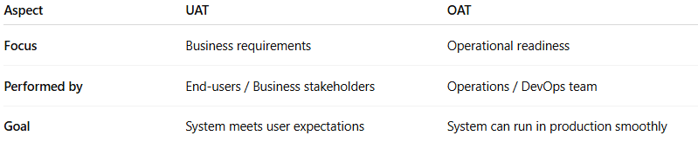
Aspect | UAT | OAT
Focus | Business requirements | Operational readiness
Performed by | End-users / Business stakeholders | Operations / DevOps team
Goal | System meets user expectations | System can run in production smoothly

✅ Other Acceptance Testing Types (for context)
# Source: Chatgpt (GPT‑5 Mini) at [8/22/2025]
- User Acceptance Testing (UAT) – Business validation.
- Contract Acceptance Testing – Compliance with contract terms.
- Regulatory Acceptance Testing – Compliance with legal/regulatory standards.
- Alpha & Beta Testing – Internal/external early user feedback.

